North Aisle -West
George Cooper-Abbs (1964)
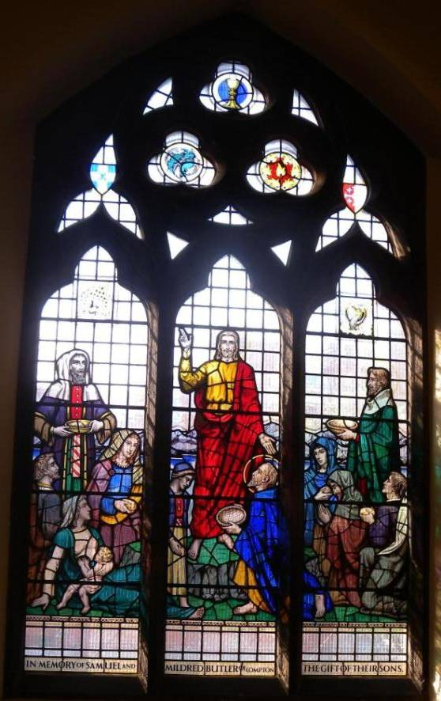

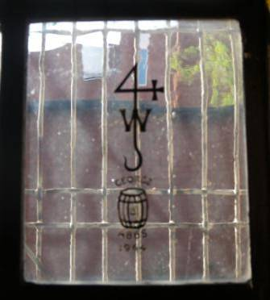

North Aisle – Centre
(C.E.Kempe & Co Ltd – c1931)

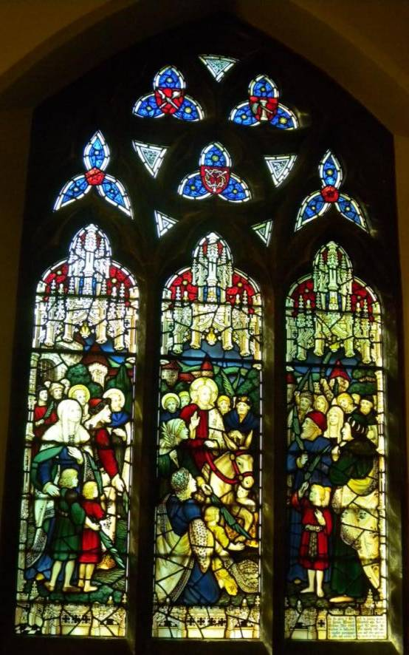

North Aisle – East
(C.E.Kempe & Co Ltd – c1931)

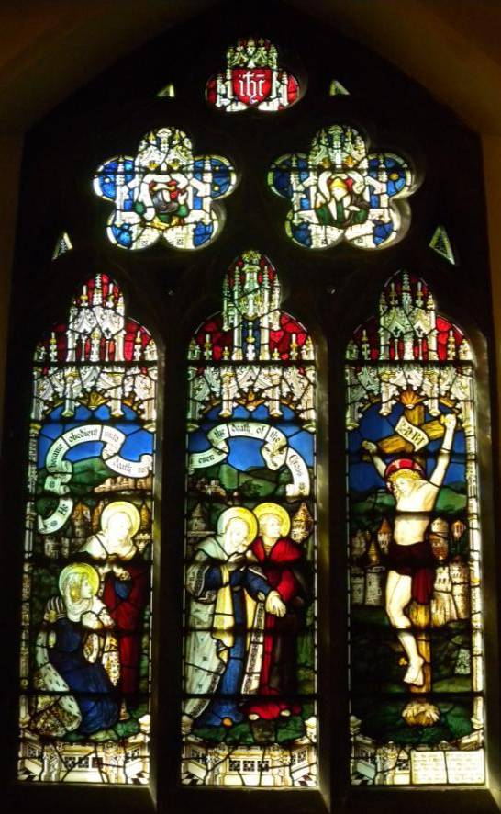

Lady Chapel
(A.J. Davies, Bromsgrove – c1931)

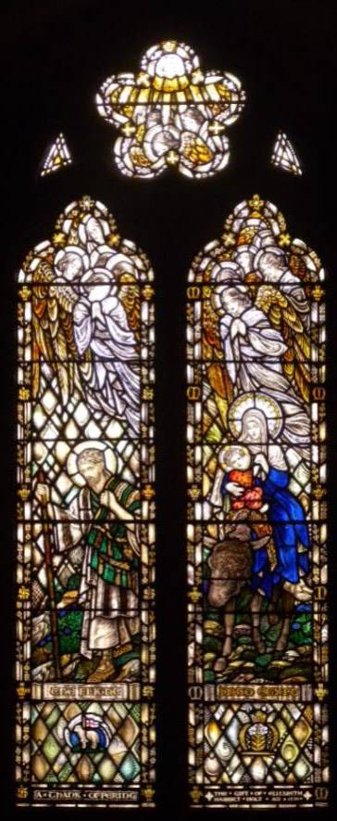

Chancel - North

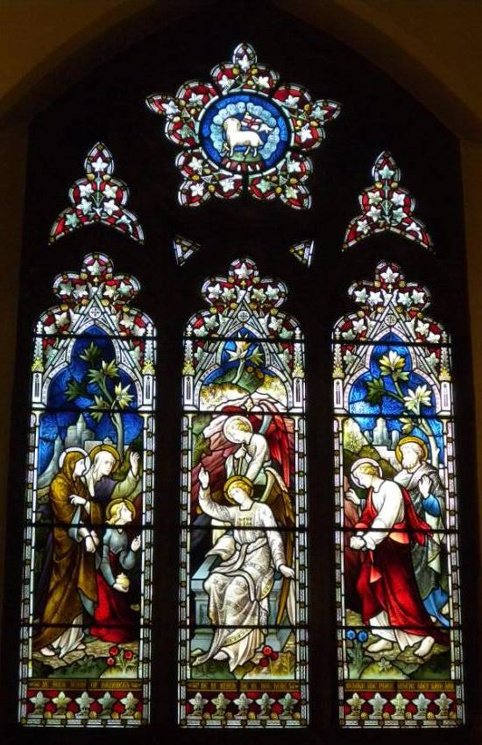

Chancel - Centre

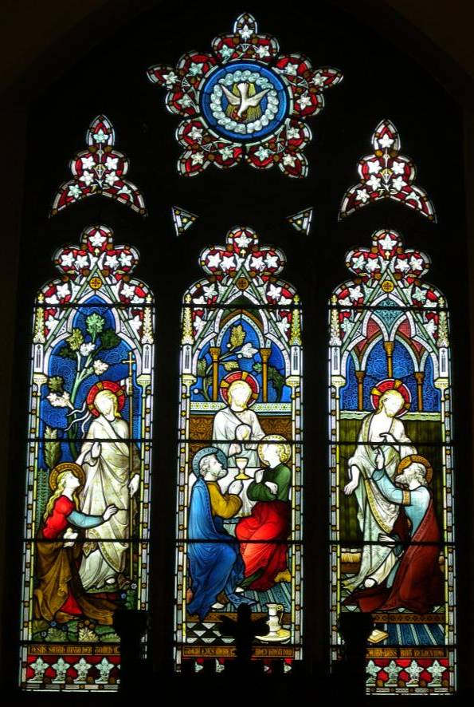

Chancel - South

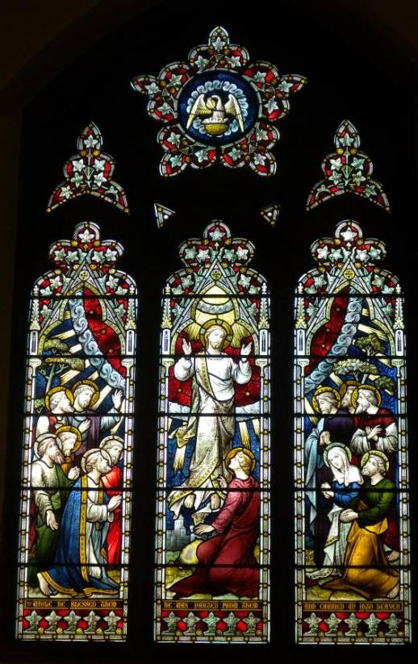

South Aisle – East
A.J. Davies, Bromsgrove – c1930)

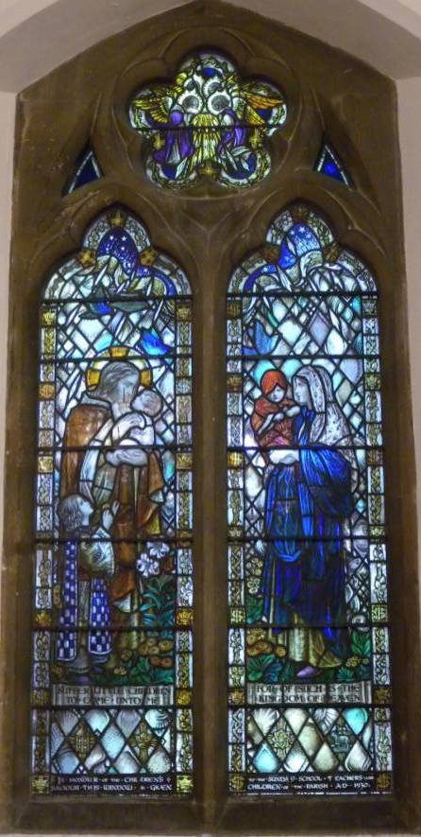

South Aisle – Centre-1
A.J. Davies, Bromsgrove – c1930

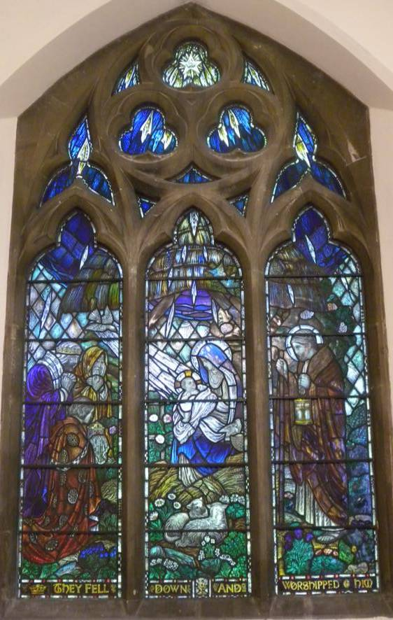

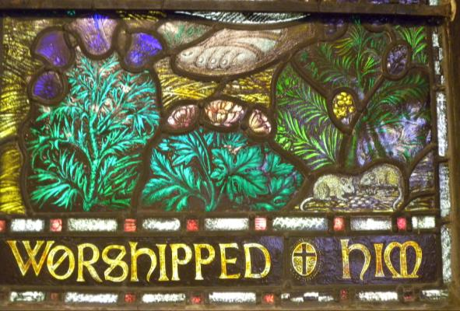

South Aisle – Centre-2
(c1958)

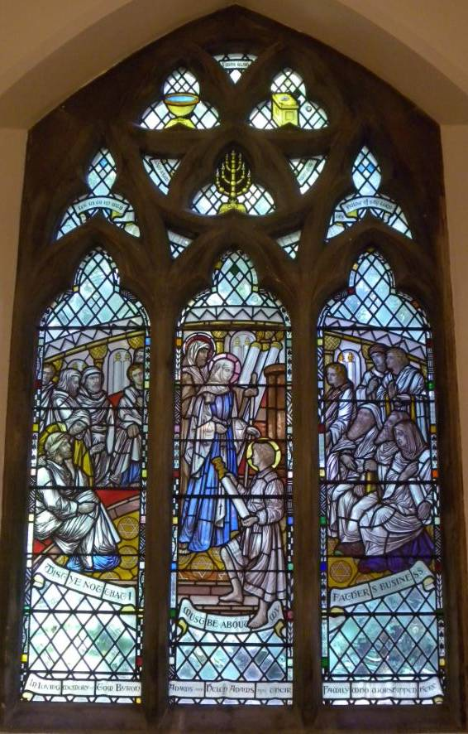

South Aisle – West
A.J. Davies, Bromsgrove – c1930

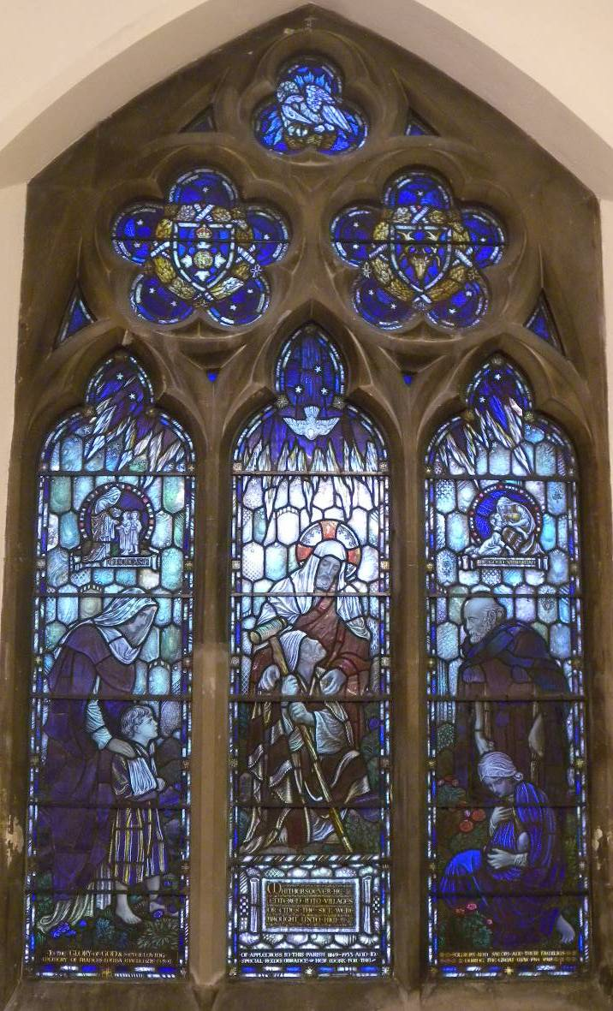

Nave - West



