TGfGF: Sermon for Sunday 17 March 2024 (Rev Phil Wootton)
John 12: 20-33 & Jeremiah 31: 31-34

‘Thank God it’s Friday: TGiF!’ they grown, wearily. Made it to the end of the week. A whole weekend ahead without having to think about work. There may be shopping, cooking, seeing relatives, taking kids here, there and everywhere, but at least it’s not work. So, TGiF – and if the marketing people have their way, it might be a meal out at the restaurant chain of the same name to celebrate: it’s Friday!

In 12 days time, we should be saying, TGfGF – Thank God for Good Friday. Thank God for the day set aside to commemorate the death of God’s Son: the day he displayed the full extent of God’s sacrificial love; the day he brought the forgiveness of sins, restored our relationship with God, and opened the way to life everlasting. Thank God for Good Friday. For me it is a great sadness that Good Friday gets passed by without even being noticed – either as another working day, or as just another public holiday. Of course, there is the general decline in religious belief and practice; of course, some people have to work to provide the services we all depend on; of course, for some it’s their only chance of holiday or to see their families. But I wonder if it’s also because the events Good Friday marks are so difficult, about suffering and death rather than fun and celebration. In church, we can happily skip from the palm waving of next Sunday to the glorious festivity of Easter, and avoid giving too much thought to what happens between the two. It’s understandable, but if we don’t follow Jesus into the depths, our faith will be shallow indeed.
This year, across the three churches of our benefice, we will mark Good Friday with services and activities of different kinds and at different times to enable as many as possible to join in. Please come! If you’re away, try and find a church where you are. If it’s not possible for you to get into church, then make space for your own thoughts, prayers and reflections. Thank God for Good Friday.

Today, the fifth Sunday of Lent, is also known as Passion Sunday – a day to look beyond the detail of the story towards meaning in Christ’s passion. On Good Friday, we imagine ourselves before the cross. Today, we take what’s hard to look at, Jesus’ blood, and Jesus’ body, and seek some form of understanding.

In recent weeks, one line of the Communion liturgy has stuck in my mind. When the chalice is raised, we have the words of Jesus: ‘This is my blood of the new covenant which is shed for you and for many for the forgiveness of sins.’ Old covenants are made throughout the Old Testament: Noah, Abraham, Moses, David. In today’s reading, the prophet Jeremiah announces God’s new covenant by which, ‘I will put my laws in their minds and write them on their hearts.’ It marks a reset in God’s relationship with his people. Jeremiah has been warning for chapter after chapter how the people were failing to keep their side of the bargain in the covenant given to Moses, that is, the 10 Commandments, written on tablets of stone. But right now, everything that he warned has come true and they’ve reached rock bottom – defeat, destruction, desolation. God’s ready for a new start. Wipe the slate clean. Forgive the past. And OK, if you find the expectations set in the covenant with Moses all too difficult, I’ll give you a new chance. I’ll start on the inside and work outwards. Instead of having to learn the law written on tablets of stone, I’ll set it in your hearts.

Jesus announces a new covenant in his blood. As in Jeremiah’s day, it is a new start, a clean slate, the forgiveness of sins. And this is for all – his blood shed ‘for you and for many.’ Rather than sealing the covenant time and again with the blood of sacrificial animals, this new covenant is sealed with the blood of Christ, once and for all. We know the rules written on our hearts and minds – love God with all that you are; love your neighbour as yourself. The Holy Spirit, released for all through Jesus’ death and resurrection, helps us out; encourage when we fall flat; prick our conscience when we’re complacent; challenges us to go further than we think possible. The law within is not an easy option, but we’re not left on our own to fulfil it. The covenant, that relationship by which God says ‘I am with you’ is renewed, permanently, by Christ’s blood, shed on the cross. Thank God for Good Friday.

The second vision is of the body of Jesus on the cross, but not as often depicted, twisted and tortured. In today’s Gospel we read Jesus saying, ‘But I, when I am lifted up from the earth, will draw all people to myself.’ Today’s passage began with disciples Philip and Andrew bringing some Greeks to see Jesus. Jesus, rather confusingly, appears to ignore them and starts talking about farming practices – burying seed in the ground, and so on. Now, think back to the first chapter of John’s Gospel: the same disciples, Philip and Andrew, invited Nathaniel to come and see Jesus, and Jesus said of Nathaniel, ‘here is a true Israelite.’ The story began when Israelites came to him. It takes a new twist when Gentiles come. Jesus has glimpsed a vision, that by his death, he will draw all people – Jews and Gentiles alike – to himself and so to God.
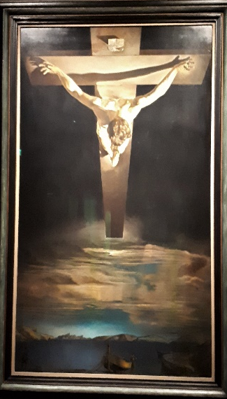
When I read in John’s Gospel that Jesus is exalted on the cross, I can’t help but think of Salvadore Dali’s extraordinary painting, Christ of St John of the Cross. Christ on the cross soars over the world, as the cross also connects earth and heaven. The scene at ground level evokes the Galilee of Jesus with its fishing boats. Sea merges with sky, and sky turns to the darkest night, into which rises the Christ so intensely lit as to be the light of the world. On the cross he has confronted and defeated the power of darkness and death by the power of pure love. For we see on his hands and feet no nail marks and there is no blood. He hangs on the cross by his own will-power – the power of his love for the world. This is the victory of the cross – crucifixion and ascension all in one. This is the Christ raised on the cross who draws all people to himself.

Thank God for Christ’s body and his blood. Thank God for Good Friday. What Jesus went through is more than we can imagine – but we should try to imagine. What Jesus achieved is more than we can get our heads around – but that doesn’t mean we shouldn’t engage our brains. This is the day that shook the world. This is the day that changed our lives. Let’s give it, let’s give him, our fullest attention. TGfGF.

