31.03.24 – Acts 10: 31-35, John 20:1-9 Rev. L. Vawer Taste and See that the Lord is Good
You will need a satsuma or similar to use as you read.
What do you expect at Easter? Easter eggs of course. And I suppose some of you will have already a tasted the delights of Easter chocolate. Theres nothing quite like it is there?
Today each of us has a satsuma – perhaps you were expecting an egg as you got here this morning but by now you will realise that you don’t quite get what you expect with this particular minister! But I’m hoping this satsuma might help us think in new way about the wonder of Easter, especially if we’ve been to many Easters before, but also if this is our first in church.
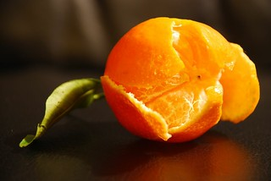
THE AROMA
First, we are going to peel the satsuma. Can you smell it? That orangey aroma? It’s a wonderful smell. But and it won’t take long, we’ll start being less aware of the smell, not because the aroma has gone but because our nose has simply got used to it. It’s become ordinary. But, if you take the peel and bring it close, you will be able to catch the fragrance again.
St Paul says to the church in Corinth when we spread the knowledge of the risen Jesus, we’re like an aroma that wafts through our world. But we can get used to that aroma. We don’t smell it anymore, we lose the wonder of Easter, it becomes ordinary. But I hope we can bring it close, and we will be able to catch the fragrance again, the knowledge of the risen Jesus!

A UNIQUE MOMENT
So, we’ve peeled our satsumas. Just have a look at it in your hand - the markings, the segments, the colour showing through the white. What you are looking at is amazing, because do you realise you are the first person ever to see the inside of this satsuma? No-one has ever seen what you are seeing. This fruit has grown secretly inside its skin, but now for the first time you have taken the peel off, you have been let in to see the wonderful unique secret of this fruit that is revealed to you.
On the first Easter Sunday, the stone of the tomb was rolled away, not to let Jesus out, but to let the disciples in, to reveal a unique sight that no-one had ever seen before. When Mary Magdalene looked in, and then Simon Peter and the other disciple looked in, they were first people ever to see the signs of resurrection. And Mary was the first person, John says, ever to see Jesus raised from the dead. They were let in to see the wonderful unique secret of the resurrection that was revealed to them, and through our readings they proclaim it to us.
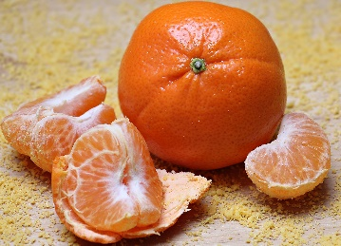
TASTE AND SEE
Well, the smell, the appearance is attractive. We want experience this and taste it don’t we? So, let’s do that. Isn’t it a lovely taste? Isn’t it good?
And the empty tomb is attractive. It shows us what Jesus means when he says he offers us life, life in all its fullness. Death is defeated, life is to be lived. And that’s attractive, and we want to experience it don’t we? Lets go inside and believe again. The psalmist says, Taste and see that the Lord is good. Come and follow him and experience what he offers.

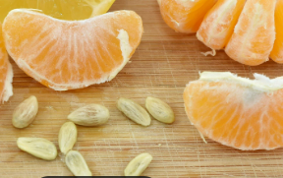
POTENTIAL FOR LIFE
Has anyone got a pip? People find them a bit annoying, so we breed fruits that are seedless, because they are easier to eat. But if a satsuma has no seeds, it has no life. There is just this fruit, no potential for a new plant, no potential for more life. So, if you have a pip, take a close look, because in that small seed there is the potential for life to grow. It points to so much more.
I wonder if we might see ourselves in this. Unique, wonderful, but small, perhaps at first glance not so significant. But there’s potential, the potential for more life. When we follow Jesus, he includes us in the growth of life that began at the empty resurrection tomb, that grew through Peter and the others proclaiming that resurrection and is still growing today as people find new life when they trust and follow the risen Jesus. When we follow, we find our potential for life to grow, in us and around us. The resurrection points to so much more.

Life is full of moments we don’t expect and non is greater than when we say Alleluia Christ is risen. He is risen indeed, Alleluia. Our journey with him will be unique, we won’t always get what we expect, but opened up for us will be the potential for life in all its fullness each and every day. Alleluia

Soon we shall share in the unique moment when our little Henry James is baptised and welcomed into the family of God. We will pray that his potential as a child of God will be fulfilled and that he will taste and see and feel the aroma of the risen Lord Jesus for all the days of his life. It is so appropriate that we will dedicate the baptismal shell to our own Rev Carol, a , unique child of God who lived her baptism potential throughout her life. With Henry let us renew our own baptism promises to reaffirm our desire to follow the risen Christ all the days of our life too.

So, in a moment to be still, enjoy the rest of the satsuma. Savour it, wonder at it. And at the same time savour this day, the fragrance of the message, the wonder of an empty tomb, the experience of Jesus, and the potential for life to grow. Taste and see that the Lord is good.

Amen

